**CTF Challenge: Using W3C Validator**

**1. Introduction**

W3C Validator is a tool that helps you validate web documents for HTML and CSS standards compliance. This challenge will introduce you to W3C Validator to gather information about the HTML and CSS compliance of a specific website.



**2. Tools and Requirements**

Access to the internet

Access to W3C Validator

**3. Scenario**

You are a web developer responsible for maintaining your company's website. Your task is to use the W3C Validator to check if your website's HTML and CSS code comply with web standards and identify any errors or warnings that need to be addressed.

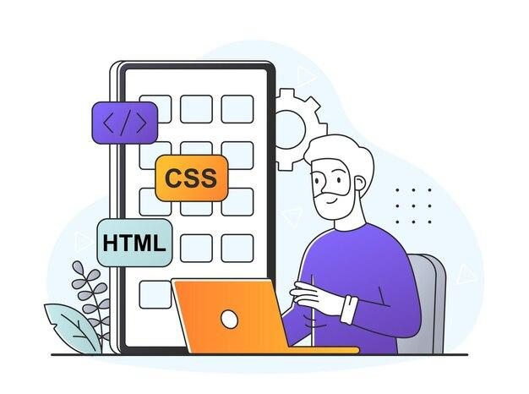

**4. Process to Follow While Performing CTF**

Step 1: Go to W3C Validator: [**https://validator.w3.org/**](https://validator.w3.org/)

Step 2: Enter the Website URL [**https://defendtheweb.net/**](https://defendtheweb.net/)in the URL input field and click on the "Check" button.

Step 3: Solve the CTF

**5. Let’s Begin the Challenge**

**Questions**

**Flag 1:** What attribute value should not be combined with a charset attribute in a meta element?

*Answer: Content-Type*

**Flag 2:** What is the issue with using a trailing slash on void elements?

*Answer: Effect*

**Hint:**



